КЫРГЫЗСКИЙ ТЕХНИЧЕСКИЙ УНИВЕРСИТЕТ им. И. Раззакова

ФАКУЛЬТЕТ ИНФОРМАЦИОННЫХ ТЕХНОЛОГИЙ

Кафедра «ПРОГРАММНОЕ ОБЕСПЕЧЕНИЕ КОМПЬЮТЕРНЫХ

СИСТЕМ»

Дисциплина

Методы оптимизации

Отчет

по практической работе №2

«Разработка ПО для поиска **максимальной и минимальной точки *экстремума*** на основе метода: ***Pocket Search Method***»

Выполнил: студент группы ПИ-2-16

Калыков Алишер

Проверил: кандидат технических наук, профессор

Тен Иосиф Григорьевич

Оглавление

Раздел №1 Наименование работы 3

Раздел №2 Спецификация проблемы 3

Раздел №3 Спецификация метода 3

Раздел №4 Стадии проектирования системы 4

Раздел №5 Документирования этапов проектирования интерфейсной формы системы 6

Раздел №6 Стадии конструирования ПО 8

Раздел №7 Тестирование 13

# Раздел №1 Наименование работы

Разработка ПО для поиска **максимальной и минимальной точки *экстремума*** на основе метода: ***Pocket Search Method.***

# Раздел №2 Спецификация проблемы

Destination/assignment of the algorithm:

To solve the one-dimensional optimization problem $extr f\left(x\right) x∈R^{1}$

using Pocket Search Method and given single an initial approximation x(0) of the searching variable value, and given an initial step size H(0), and given any significance value of digit position R with a required error tolerance tol.

# Раздел №3 Спецификация метода

|  |  |
| --- | --- |
| Mathematical Description of Algorithm of the PSM | Computational Description of Algorithm of the PSM |
| |IF fk >= fk-1 /*Pocket Search Method to find a ***minimum*** */  | |THEN  | | |IF |hk| <= ε/R  | | | |THEN hk+1 = hk; xk+1 = xk; fk+1 = fk;  | | | |ELSE hk+1 = – hk/R; xk+1 = xk+ hk+1; fk+1 = f(xk+1);  | | |endIF  | |ELSE hk+1 = hk; xk+1 = xk+ hk+1; fk+1 = f(xk+1);  |endIF  for k=1, 2, …; | **INPUT** {X0; Epsilon; H0; R; Max; f(X);}  **Body of algorithm**  YF0: = f (X0);  H1: = H0;  X1: = X0 + H1;  YF1: = f(X1);  K:=0;  |WHILE K < Max DO  | K: = K+1;  | |IF YF1 >= YF0 /* Pocket Search Method to find a ***minimum* */**  | | |THEN  | | | |IF abs(H0) < (Epsilon/R)  | | | | |THEN DO H1: = H0; X1: = X0; YF1: = YF0; END;  | | | | |ELSE DO H1: = – (H0/R); H0: = H1;  | | | | X0: = X1; YF0: = YF1;  | | | | X1: = X0 + H1; YF1: = f(X1); END;  | | | |endIF  | | |ELSE DO H1: = H0; X0: = X1; YF0: = YF1;  | | X1: = X0 + H1; YF1: = f(X1); END;  | |endIF;  |endWHILE;  **OUTPUT**  PRINT ‘The optimum solution x* equal’ X1  PRINT ‘The optimum solution was found with the desired tolerance’ Epsilon  PRINT ‘The minimum of objective function f(x*) is’ YF1  PRINT ‘The accuracy is ±‘ Epsilon |
| x0 – Initial approximation of the solution;  h0 – Initial Increment (Initial Step-size of search);  ε – Tolerance;  R – Adjustable parameter of the method (Significance of Digit Position);  fk = f(xk) – objective function at point xk. | X0 – Initial approximation of the solution;  H0 – Initial Increment (Initial Step-size of search);  Epsilon – Tolerance;  R – Adjustable parameter of the method (Significance of Digit Position);  Max – Limit number of iterations. |

# Раздел №4 Стадии проектирования системы

1. Разработка блок-схемы Pocket Search Method:

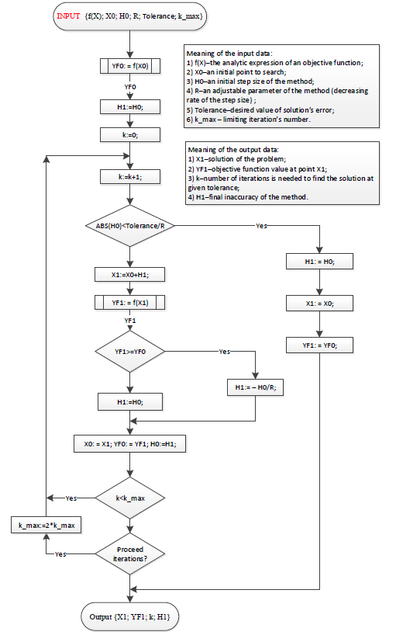

1. Разработка пользовательского интерфейса.

Форма для взаимодействия пользователя с программой представлена ниже:

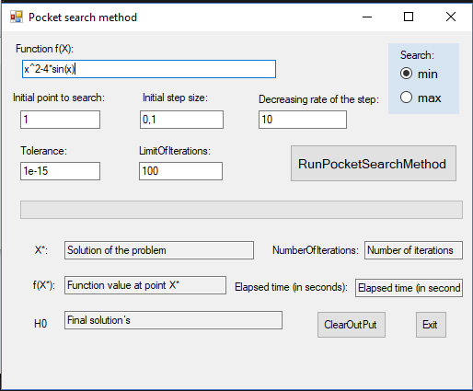

# Раздел №5 Документирования этапов проектирования интерфейсной формы системы

1. Документирование процесса задания свойств элементов интерфейсной формы системы



1. Таблица 1: Настройки элементов управления интерфейсной формы системы

|  |  |  |  |
| --- | --- | --- | --- |
| **Number of control** | **Control** | **Property** | **Setting** |
| 1 | Label1 | Appearance (Text) | Function f(x): |
| Design (Name) | Label1 |
| 2 | Textbox1 | Appearance (Text) | x^2-4*sin(x) |
| Design (Name) | funcBox |
| 3 | Label2 | Appearance (Text) | Initial point to search: |
| Design (Name) | LabelInitialPoint |
| 4 | Textbox2 | Appearance (Text) | 1 |
| Design (Name) | InitialPointBox |
| 5 | Label3 | Appearance (Text) | Initial step size: |
| Design (Name) | InitialStepLabel |
| 6 | Textbox3 | Appearance (Text) | 0.1 |
| Design (Name) | InitialStepBox |
| 7 | Label12 | Appearance (Text) | Decreasing rate of the step: |
| Design (Name) | DecreasingLabel |
| 8 | Textbox11 | Appearance (Text) | 10 |
| Design (Name) | DecreasingBox |
| 9 | Label4 | Appearance (Text) | LimitOfIterations: |
| Design (Name) | LabelLimitOfIterations |
| 10 | Textbox4 | Appearance (Text) | 100 |
| Design (Name) | k_maxBox |
| 11 | Label5 | Appearance (Text) | Tolerance |
| Design (Name) | LabelTolerance |
| 12 | Textbox5 | Appearance (Text) | 1e-15 |
| Design (Name) | ToleranceBox |
| 13 | Button1 | Appearance (Text) | RunBisectionMethod |
| Design (Name) | ButtonRunPocketSearchMethod |
| 14 | ProgressBar1 | Behavior (Visible) | False |
| Design (Name) | ProgressBar1 |
| 15 | Label6 | Appearance (Text) | Root is X*: |
| Design (Name) | LabelRootOfEquation |
| 16 | Textbox6 | Design (Name) | SolutionOfTaskBox |
| Appearance (Text) | Solution of the problem |
| **Behavior (ReadOnly)** | True |
| 17 | Label7 | Appearance (Text) | f(X*): |
| Design (Name) | LabelFunctionValue |
| 18 | Textbox7 | **Behavior (ReadOnly)** | True |
| Appearance (Text) | Function value at point X* |
| Design (Name) | ValueOfFunctionBox |
| 19 | Label8 | Appearance (Text) | NumberOfIterations: |
| Design (Name) | Label NumberOfIterations |
| 20 | Textbox8 | **Behavior (ReadOnly)** | True |
| Appearance (Text) | Number of iterations |
| Design (Name) | NumberOfIterationsBox |
| 21 | Label9 | Appearance (Text) | H0 |
| Design (Name) | LabelAbsError |
| 22 | Textbox9 | **Behavior (ReadOnly)** | True |
| Appearance (Text) | Final inaccurancy |
| Design (Name) | H0box |
| 23 | Button2 | Appearance (Text) | ClearOutPut: |
| Design (Name) | ButtonClearOutPut |
| 24 | Textbox10 | **Behavior (ReadOnly)** | True |
| Design (Name) | elapsedTime |
| 25 | Label10 | Appearance (Text) | Elapsed time (in seconds): |
| Design (Name) | Label3 |
| 26 | Label11 | Appearance (Text) | empty |
| Design (Name) | Label4 |
| 27 | Button3 | Appearance (Text) | Exit |
| Design (Name) | Button3 |
| 28 | RadioButton | Appearance (Checked) | True |
| Appearance (Text) | min |
| Design (Name) | minRadioButton |
| 29 | RadioButton | Appearance (Checked) | False |
| Appearance (Text) | max |
| Design (Name) | maxRadioButton |

# Раздел №6 Стадии конструирования ПО

1. Код программы на Visual Basic.NET, ***ассоцированный с интерфейсной формой*** “PocketForm.vb”, который ***реализует функции ввода и вывода данных*** и составляет Public Class “PocketForm”.

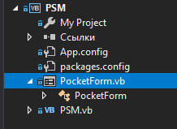



*********************Outset of the “Public Class PocketForm”

Option Explicit On

Imports System.Math

Imports info.lundin.math

Imports System.Threading

Public Class PocketForm

Sub Clean()

SolutionOfTaskBox.Text = "Solution Of Task"

ValueOfFunctionBox.Text = "Value Of Function"

NumberOfIterationsBox.Text = "Number Of Iterations"

elapsedTime.Text = "Elapsed time (in seconds)"

H0box.Text = "Final solution’s"

Label4.Text = ""

End Sub

Private Sub Form4_Load(sender As Object, e As EventArgs) Handles MyBase.Load

Label2.Text = ""

SolutionOfTaskBox.Text = "Solution of the problem"

ValueOfFunctionBox.Text = "Function value at point X*"

NumberOfIterationsBox.Text = "Number of iterations"

elapsedTime.Text = "Elapsed time (in seconds)"

H0box.Text = "Final solution’s"

Label4.Text = ""

End Sub

Private Sub ButtonExit_Click_1(sender As Object, e As EventArgs) Handles ButtonExit.Click

Close()

End Sub

Private Sub ButtonClearOutPut_Click(sender As Object, e As EventArgs) Handles ButtonClearOutPut.Click

Clean()

End Sub

Private Sub ButtonRunPocketSearchMethod_Click(sender As Object, e As EventArgs) Handles ButtonRunPocketSearchMethod.Click

Dim started As DateTime = Now

Dim finished As DateTime

ProgressBar1.Value = 0

Try

If (funcBox.Text = "" Or InitialPointBox.Text = "" Or InitialStepBox.Text = "" _

Or DecreasingBox.Text = "" _

Or ToleranceBox.Text = "" Or k_maxBox.Text = "") Then

MsgBox("Input textboxes are empty! Enter the data")

Else

Clean()

Dim PM As PSM = New PSM()

Label2.Text = "Analytical expression of the function is: f(x) = " & funcBox.Text

PM.start(funcBox, InitialPointBox, ToleranceBox,

k_maxBox, DecreasingBox, InitialStepBox, minRadioButton, maxRadioButton,

ProgressBar1, Label4, H0box)

finished = Now

elapsedTime.Text = finished.Subtract(started).Seconds

PM.out(SolutionOfTaskBox, ValueOfFunctionBox, NumberOfIterationsBox, H0box)

End If

Catch ex As ParserException

MsgBox("A mistake is in the analytical expression of the function f(x)")

Catch ef As FormatException

MsgBox("A mistake is in the format of the input data")

End Try

End Sub

End Class

***********************Ending of the “Public Class PocketForm”

1. Код класса “PSM.cs”

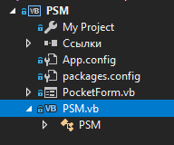

*********************Outset of the “Public Class PSM”

Option Explicit On

Imports System.Math

Imports info.lundin.math

Imports System.Threading

Public Class PSM

Dim func As String

Dim k As Integer

Dim SolutionOfTask As Decimal

Dim ValueOfFunction As Decimal

Dim FinalInaccuracy As Decimal

Dim FinalH0 As Decimal

Public Sub out(SolutionOfTaskBox As TextBox, ValueOfFunctionBox As TextBox,

NumberOfIterationsBox As TextBox, H0box As TextBox)

SolutionOfTaskBox.Text = SolutionOfTask

ValueOfFunctionBox.Text = ValueOfFunction

NumberOfIterationsBox.Text = k

H0box.Text = FinalH0.ToString("0E0")

End Sub

Function F(par As Double) As Double

Dim Parser As New ExpressionParser()

Parser.Values.Add("x", par)

Return Parser.Parse(func)

End Function

Public Sub start(funcBox As TextBox, InitialPointBox As TextBox,

ToleranceBox As TextBox, k_maxBox As TextBox,

DecreasingBox As TextBox, InitialStepBox As TextBox,

minRadioButton As RadioButton, maxRadioButton As RadioButton,

ByRef ProgressBar1 As ProgressBar, ByRef Label4 As Label, H0box As TextBox)

Dim Tolerance As Double

Dim x0, x1 As Decimal

Dim R As Decimal

Dim H0, H1 As Decimal

Dim YF0, YF1 As Decimal

Dim k_max As Integer

func = funcBox.Text

x0 = Decimal.Parse(InitialPointBox.Text)

Tolerance = Double.Parse(ToleranceBox.Text)

k_max = Integer.Parse(k_maxBox.Text)

R = Decimal.Parse(DecreasingBox.Text)

H0 = Decimal.Parse(InitialStepBox.Text)

Dim searchMin As Boolean

Dim searchMax As Boolean

searchMin = Boolean.Parse(minRadioButton.Checked)

searchMax = Boolean.Parse(maxRadioButton.Checked)

YF0 = F(x0)

H1 = H0

x1 = x0 + H1

YF1 = F(x1)

k = 0

If searchMin = True And searchMax = False Then

Do

k = k + 1

If YF1 >= YF0 Then

If Abs(H0) <= CDec(Tolerance / R) Then

H1 = H0

x1 = x0

YF1 = YF0

Label4.Text = "Answer: The minimum find with the given Tolerance = " & Tolerance

Exit Do

Else

H1 = -H0 / R

H0 = H1

End If

Else

H1 = H0

End If

x0 = x1

YF0 = YF1

x1 = x0 + H1

YF1 = F(x1)

ProgressBar1.Visible = True

ProgressBar1.Maximum = k + 0.00000001

ProgressBar1.Value = k

Thread.Sleep(0)

If k = k_max Then

Dim rv As Long

rv = MsgBox("Attention: It isn't possible to find a solution with the given Tolerance = " & Tolerance & " and for a given Number Of Iterations =" & k_max & vbCrLf & "Continue searching?", vbYesNo Or vbQuestion)

If rv = vbYes Then

k_max = k_max + k_max

k_maxBox.Text = k_max

End If

End If

Loop While k < k_max

If k >= k_max Then

Label4.Text = "Attention: It isn't possible to find a solution with the given Tolerance = " & Tolerance & vbCrLf & "and for a given Number Of Iterations =" & k_max

End If

ElseIf searchMin = False And searchMax = True Then

Do

k = k + 1

If YF1 <= YF0 Then

If Abs(H0) <= CDec(Tolerance / R) Then

H1 = H0

x1 = x0

YF1 = YF0

Label4.Text = "Answer: The maximum find with the given Tolerance = " & Tolerance

Exit Do

Else

H1 = -H0 / R

H0 = H1

End If

Else

H1 = H0

End If

x0 = x1

YF0 = YF1

x1 = x0 + H1

YF1 = F(x1)

ProgressBar1.Visible = True

ProgressBar1.Maximum = k + 0.00000001

ProgressBar1.Value = k

Thread.Sleep(0)

If k = k_max Then

Dim rv As Long

rv = MsgBox("Attention: It isn't possible to find a solution with the given Tolerance = " & Tolerance & " and for a given Number Of Iterations = " & k_max & vbCrLf & "Continue searching?", vbYesNo Or vbQuestion)

If rv = vbYes Then

k_max = k_max + k_max

k_maxBox.Text = k_max

End If

End If

Loop While k < k_max

If k >= k_max Then

Label4.Text = "Attention: It isn't possible to find a solution with the given Tolerance = " & Tolerance & vbCrLf & "and for a given Number Of Iterations = " & k_max

End If

Else

MsgBox("Error when choosing min/max: min = " & searchMin & " and max = " & searchMax)

End If

ProgressBar1.Visible = False

SolutionOfTask = x1

ValueOfFunction = YF0

FinalH0 = Abs(H1)

End Sub

End Class

*********************Ending of the “Public Class PSM”

# Раздел №7 Тестирование

1. Тест №1 функция: x^2-4*sin(x)

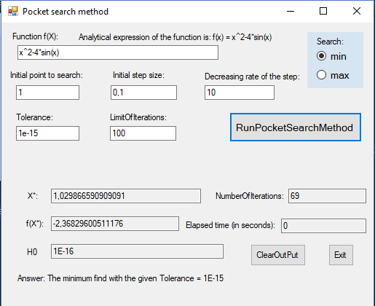

Min

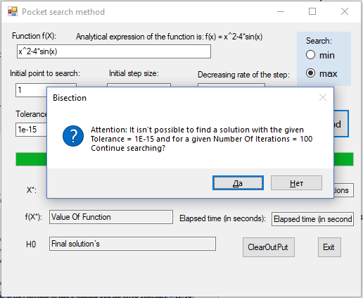

Max

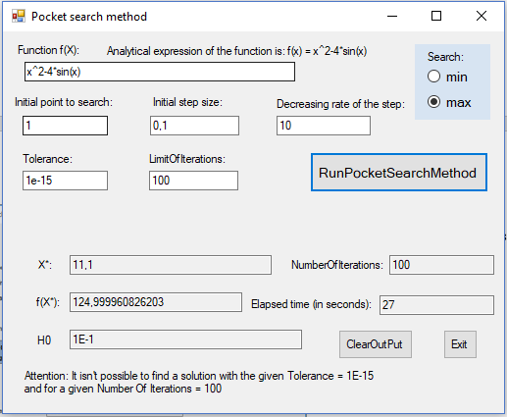

Не найдено решение за указанное количество итерации.

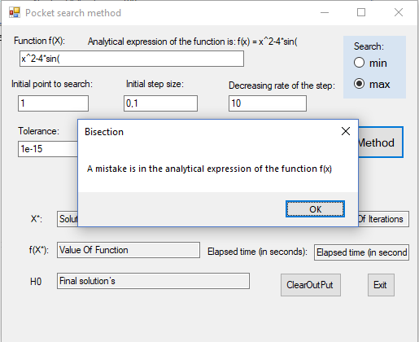

Ошибка в выражении функции f(x)

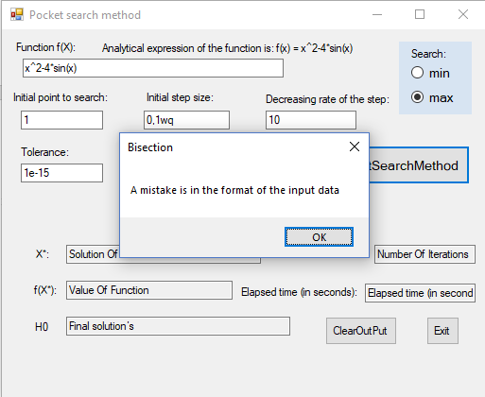

Ошибка в формате входных данных.